**Project Title:** Car Resale Value Prediction **Project Design Phase-I** - **Solution Fit Template Team ID:** PNT2022TMID16841

**Identify strong TR & EM**

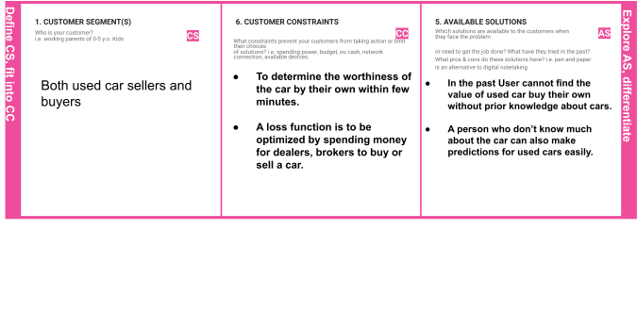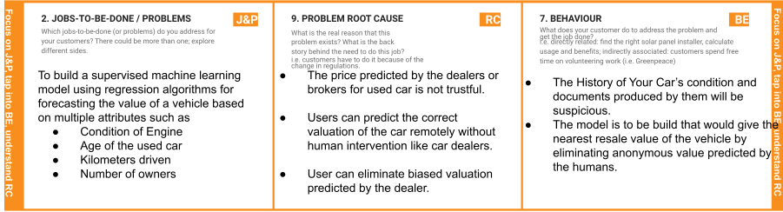

## 3. TRIGGERS TR

What triggers customers to act? i.e. seeing their neighbour installing solar panels, reading about a more efﬁcient solution in the news.

# User can predict the correct valuation of the car by their own like olx,car24 and other car resale value prediction websites by using model, year, owner, etc.

**10. YOUR SOLUTION SL**

If you are working on an existing business, write down your current solution ﬁrst, ﬁll in the canvas, and check how much it ﬁts reality.

If you are working on a new business proposition, then keep it blank until you ﬁll in the canvas and come up with a solution that ﬁts within customer limitations, solves a problem and matches customer behaviour.

# The main aim of this project is to predict the price of used cars using the Machine Learning (ML) algorithms and collection data’s about different cars. The project should take parameters related to used car an inputs and enable the customers to make decisions by their own.

# **8.CHANNELS OF BEHAVIOUR CH**

### 8.1-ONLINE

What kind of actions do customers take online? Extract online channels from #7

### 8.2 -OFFLINE

What kind of actions do customers take ofﬂine? Extract ofﬂine channels from #7 and use them for customer development.

## Customer should predict the worth of the car by using different parameters given by the owner.

* + - **User should conﬁrm the details provided about the vehicle in RTO online.**

## User can decide by seeing the exterior and interior condition of the car.**User can test the performance of the car and to buy it up in a affordable price based on its condition.**

**4. EMOTIONS: BEFORE / AFTEREM**

How do customers feel when they face a problem or a job and afterwards?

i.e. lost, insecure > conﬁdent, in control - use it in your communication strategy & design.

**Before:**

User will be in fear about the biased values predicted by the humans based on the condition of the car.

**After:**

User can determine the worthiness of the car by their own without human intervention.